DECLARATION OF COVENANTS AND RESTRICTIONS

This Declaration of Covenants and Restrictions (“Declaration”) made this day of 2013, by , a(n) , with a mailing notice of (“Declarant”), is to evidence the following:

W I T N E S S E T H

WHEREAS, Declarant owns approximately _____ acres of land located in Orange Village (the “Village”) described in Exhibit “A” attached hereto and made a part hereof, and as shown on Exhibit “B” (hereinafter referred to as the “Development Property”); and

WHEREAS, Declarant desires to develop the Development Property for mixed-use development in accordance with the provisions of Ordinance No. 2013-11 (the “Ordinance”) and that certain Development Agreement between the Declarant and the Village dated , 2013; and

WHEREAS, the Development Property is adjacent to approximately ____ acres of land in the Village known as PD-6 Sub-District in the Ordinance, described in Exhibit “C” attached hereto and made a part hereof, and as shown on Exhibit “D” (the “Restricted Property”) (the “Development Property and the Restricted Property, together the “Property”), which Restricted Property is presently improved with single-family dwellings; and

WHEREAS, the Restricted Property is also adjacent to parcels of property with street addresses on Waterford Court, Orange Village, Ohio, which parcels have been assigned Cuyahoga County Permanent Parcel Nos. 901-02-002, 901-02-033, 901-02-034, 901-02-035, 901-02-040, 901-02-041, and 901-02-042 (each, an “Abutting Property” and collectively, the “Abutting Properties”); and

WHEREAS, the owners of the Abutting Properties (individually, an “Owner” and collectively, the “Owners”) are intended beneficiaries of this Declaration, with the right to enforce the provisions hereof individually and/or collectively; and

WHEREAS, the Declarant, for itself and all future owners of all or any part of the Development Property, desires to hold its interest in the Development Property subject to the terms hereof, and restrict the Restricted Property as set forth in this Declaration.

NOW, THEREFORE, intending to be legally bound, Declarant, for itself and its successors and assigns and all future owners of all or any part of the Development Property, hereby covenants and declares that:

- Restrictions on the Use and Improvement of the Restricted Property. No use of, or improvements to, the Restricted Property, or any portion thereof, shall be made except as follows, and the Property shall be subject to the following covenants and restrictions:
  - The Restricted Property shall be maintained as open space, with no above-ground improvements, except the Mound (hereinafter defined), the Wall (hereinafter defined) and the Landscaping (hereinafter defined), subject to the following further restrictions, as herein provided.
  - Prior to the construction of any improvements on the Development Property (except as provided below), Declarant, at its sole cost and expense, shall:
    - construct an earthen mound (the “Mound”) within the boundaries of the Restricted Property with a configuration and dimensions substantially in accordance with the Preliminary Grading Plan attached hereto as Exhibit “E” and made a part hereof, and the landscape plan of Cawrse & Associates, Inc. attached hereto and made a part hereof as Exhibit “F” (the “Cawrse Plan”); and
    - construct a continuous wall (the “Wall”), the height of which Wall will be substantially in accordance with Exhibit “G” hereto (the “Site Line Drawing”) and the face of which shall be planted with ivy or other creeping plants and as otherwise in accordance with the Cawrse Plan; and
    - landscape the Restricted Property substantially in accordance with the Cawrse Plan (hereafter, “Landscaping”).
Other than demolition of structures and excavation or grading of the Development Property and Restricted Property and the installation of underground improvements on the Development Property, no improvements of any kind or nature shall be made to the Development Property until the Mound and Wall are constructed and the Landscaping is installed.
  - At all times, Declarant, at its sole cost and expense, shall:
    - Insure the Mound and Wall and maintain, repair and replace the same, and irrigate the Mound, as reasonably necessary to keep the same at all times in good condition and so that there is no material change in their condition from the condition when approved by the Owners’ landscape architect as herein provided; and
    - maintain, repair and replace, and irrigate the Landscaping as reasonably necessary to ensure the same is at all times in good condition and that there is no material decrease in the buffering provided by the Landscaping.
  - Declarant shall be liable for (and pay when due) all real estate taxes and insurance relating to the Restricted Property. The form and amount of such insurance shall be subject to the Village’s reasonable approval.
  - Except for the Wall, the Mound and the Landscaping, no above-ground improvements to the Restricted Property shall be permitted.
  - No vehicular or pedestrian access to, from or on the Restricted Area shall be permitted, except as reasonably necessary to install and maintain, repair, and replace the Wall, to install and maintain, repair, replace and irrigate the Mound, and to install, maintain, repair, replace, and irrigate the Landscaping, and then such work shall be performed between the hours of 7:30 a.m. and 5:30 p.m., Monday through Friday, provided that in the event that construction of the Mound Wall and Landscaping work falls behind Developer’s schedule therefor Developer shall be permitted to also perform such work on no more than one Saturday per month between the hours of 8:00 a.m. and 5:30 p.m. Such work shall be performed utilizing generally accepted commercial construction practices and procedures; provided, however, that if there exists more than one generally accepted commercial construction practice and procedure to perform any such work that Declarant reasonably determines to be of comparable cost, such work shall be performed using the practice and procedure that will cause less interference or disruption to the Owners.
  - At Declarant’s expense (not to exceed $8,000.00), a landscape architect selected by the Owners shall be permitted to inspect the Restricted Property during and following installation of the Mound and the Landscaping to ensure that they are installed substantially in accordance with this Declaration (including, without limitation, the Cawrse Plan), and if such architect determines upon any such inspection that the same has not been so installed, then such architect shall advise Declarant in writing of the same promptly following the inspection revealing that the Mound or Landscaping are not so installed, and Declarant shall promptly remedy the same.
  - Following installation of the Mound, Declarant shall cause access to the Restricted Area from the Development Property to be secured so as to allow access to or from the Restricted Area solely (i) to the extent necessary to maintain, repair, replace and irrigate the Mound and to install, maintain, repair, replace and irrigate the Landscaping; and (ii) by the Owners of the property adjacent thereto for pedestrian purposes only.
- Performance Bond/Letter of Credit. Prior to the construction of any improvements on the Property (including, without limitation, grading of any portion of the Property), Declarant shall arrange for the provision and securing of and provide to the Village a payment and performance bond, standby letter of credit that is irrevocable without the Village’s agreement, or other financial guarantee acceptable to, and in favor of, the Village and in an amount determined by the Village to be sufficient to construct and pay for in full the Mound, Wall and Landscaping.
- Enforcement. This Declaration is intended for the sole benefit of the Village and the Owners and may be enforced by the Village and/or the Owners (individually and/or collectively); provided, however, that:
  - Any Owner shall be permitted to take any action in court to enforce this Declaration or declare its terms, provided the following has occurred:
    - such Owner has provided the Village and Declarant notice in writing of Declarant’s purported violation of this Declaration and within thirty (30) days after date of such notice, Declarant has failed to cure such purported violation (or, if such purported violation cannot reasonably be cured within such thirty (30) day period, Declarant has failed to commence to remedy such purported violation within the thirty (30) day period and proceed thereafter with due diligence until completion and completed the same within sixty (60) days of the date of such notice or such additional period of time as weather permits (such period, the “Default Period”).
    - Such Owner (the “Notifying Owner”) has, after expiration of the Default Period, attempted in good faith to resolve any dispute, claim or controversy arising out of or relating to the purported violation of this Declaration identified in the notice required hereunder by mediation before a mediator (and at a date, time and location in Cuyahoga County, Ohio) mutually agreed upon by the Notifying Owner and Declarant or, if such Notifying Owner and the Declarant cannot so agree, before a mediator (and at a date, time and place in Cuyahoga County, Ohio) determined by the Village’s Mayor; provided, however, that in no event shall such mediation take place more than thirty (30) days after the Default Period and, if such mediation does not occur within such thirty (30) day period, the parties shall be relieved of any requirement to mediate. The Notifying Owner shall notify the Village and all other Owners of such mediation and invite them to participate in such mediation. The Notifying Owner and Declarant shall share equally the costs and expenses of the mediator (which shall not include, and each party shall bear, the expenses incurred by each party for its own legal representation in connection with any mediation). Such mediation shall constitute settlement negotiations, and, to the extent allowed by applicable law, all offers, promises, conduct and statements, whether oral or written, made in the course of such mediation by any of the parties or their agents shall be confidential and inadmissible in any other legal proceeding, provided, however, that evidence which is otherwise admissible or discoverable shall not be rendered inadmissible or non-discoverable as a result of its use in the mediation.
  - Any Owner who, after complying with the provisions of Subsections 3(a) above, initiates an action in court to enforce this Declaration or declare its terms shall, to the extent required by law, name as necessary parties thereto Declarant, all other Owners, and the Village.
- Amendment. This Declaration may be modified, amended or revoked by the Declarant, its successors and assigns, in whole or in part, only with the written consent of the Village by an ordinance enacted by its Council and with the written consent of all Owners.
- Successors in Interest. This Declaration shall be binding upon Declarant and its successors in interest and assigns in perpetuity. All terms and provisions created, granted or reserved herein shall be deemed to be covenants running with the Restricted Property and the Property in perpetuity, and shall be binding upon the grantee on each and every instrument of conveyance.
- Effective. This Declaration shall become effective only at such time as:
  - the Ordinance has been enacted by the Village; and
  - the Ordinance has been submitted to and approved by the electors of the Village and the electors of the precinct in which the Property is located at the November 5, 2013 General Election pursuant to Article III, Section 13 et seq. of the Village Charter.
7. No Waiver of Covenants and Restrictions. None of the provisions herein shall be deemed to have been abrogated or waived by reason of any failure to enforce the same, irrespective of the number of violations or breaches which may occur.
8. Enforceability of Covenants and Restrictions. The invalidity of any of the terms or provisions herein shall not impair or affect in any manner whatsoever the validity, enforceability or effect of the remaining terms and provisions herein.
9. Relation to Zoning Code. The terms and provisions herein shall in no way affect the provisions now or hereafter contained in the Zoning Code of the Village of Orange, Ohio or other governmental regulations, but all land, buildings and other structures on the Property shall in all cases satisfy such terms and provisions herein, as well as the provisions of such Zoning Code and other governmental regulations, from time to time in effect. In the event of a conflict between the terms and provisions herein and any governmental law, rule or regulation, such as the Zoning Code of the Village of Orange, Ohio, the requirements which impose the greater restrictions shall control.
10. Representations and Warranties of Declarant. Declarant represents and warrants that (a) Declarant is the fee simple owner of all of the Property and has the full right and authority to execute, deliver and comply with this Declaration, and this Declaration is a binding and enforceable obligation of Declarant; and (b) this Declaration has priority over any mortgage or encumbrance affecting the Property or any part thereof or interest therein.

(signature page follows)
IN WITNESS WHEREOF, this Declaration of Covenants and Restrictions is executed by Declarant this ____ day of ___________________ 2013.

[OWNER]
By:
Name:
Title:

STATE OF OHIO )
) SS:
COUNTY OF CUYAHOGA )

Before me, a Notary Public in and for said county and state, personally appeared the above-named _____________, a(n) __________, by _________________, its , who acknowledged that he/she did sign the foregoing instrument and that the same is his/her free act and deed individually and as ___________ of said .

IN WITNESS WHEREOF, I have hereunto set my hand and notarial seal at __________________________, Ohio, this ___ day of _________________ 2014.

_________________________________
NOTARY PUBLIC

This instrument prepared by:
Jordan Berns, Esq.
BERNS, OCKNER & GREENBERGER, LLC
3733 Park East Drive, Suite 200
Beachwood, Ohio 44122
EXHIBIT “A”

EXHIBIT “B”

EXHIBIT “C”

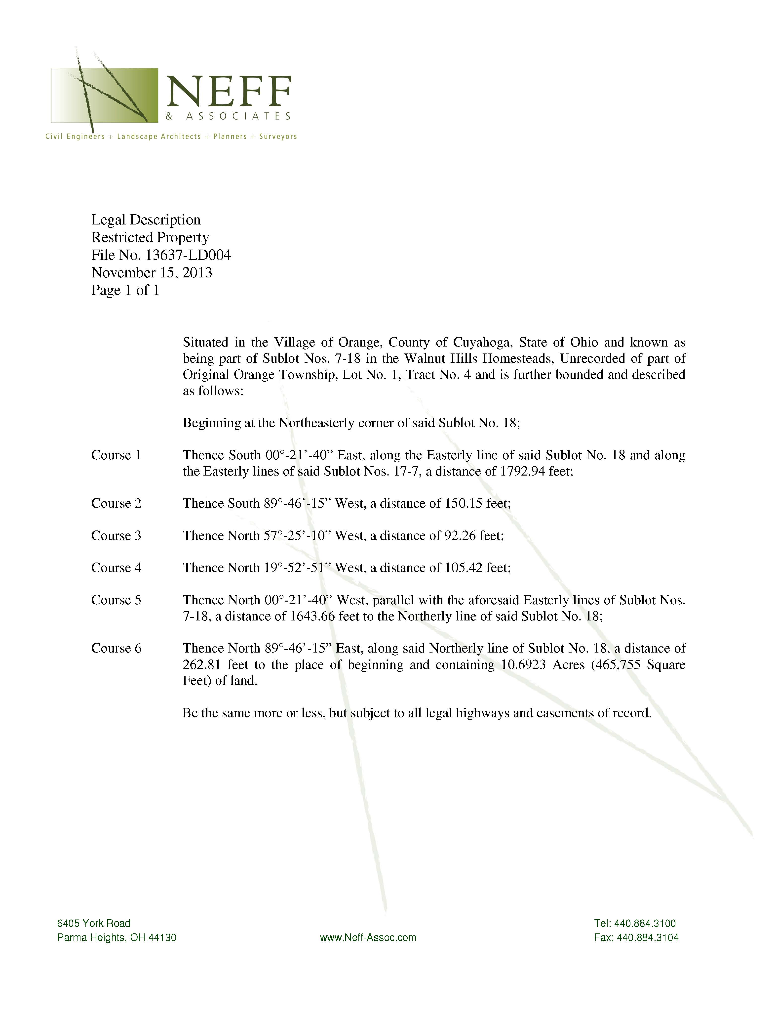
EXHIBIT “D”



